John Szostak

**Fujita, Tsuguharu** (藤田嗣治, **1886-1968)**

Fujita Tsuguharu (Fujita Tsuguji and Léonard Foujita) was a Japanese oil painter who spent most of his career in France. He is known in the West for female nudes and portraits painted in the 1920s with a distinctive pearl-white pigment, executed in a style that melds French modernism with the linear aesthetics of traditional Japanese prints. These paintings, which frequently featured cats, won him both critical and popular acclaim, earned him membership in the Salon d’Automne, and made him a mainstay of the Montparnasse artist community. He is the sole Japanese painter associated with the École de Paris. Fujita returned to Japan in 1933, where he exerted substantial influence on contemporary painting as a member of the Second Section Society (Nikakai). During the Pacific War, Fujita created many large-scale works for the Japanese military as an official war artist, activities that continue to affect his reputation in Japan today. Difficulties adjusting to the post-war cultural landscape of Japan led Fujita to return to France in 1950, where he revitalized his career. He become a French citizen in 1955, and was awarded the Legion of Honor in 1957.

Born in Tokyo, Fujita graduated in 1910 from the Tokyo School of Fine Arts. In 1913 he moved to Paris, where he came to know Picasso, Modigliani and Soutine. After achieving minor success in the 1910s with Cubist-style landscapes, in 1919 he adopted a nearly monochromic, linear style of figure painting, an example of which is *Nude Reclining Amidst Toile Cloth* his debut work at the Salon d’Automne. The painting, which offers nods to both Manet’s *Olympia* (1863) and Japanese print artists such as Utamaro, is one of many white-on-white nude studies Fujita created in the 1920s. Fujita experimented by combing lead-white oil paint, talc, kaoline, and Japanese ground seashell pigments to create the flat, milk-white tones for his model’s skin, and to supply a surface suitable for the fine black ink outlines he used to define forms.

In 1931 Fujita left France and returned to Japan, touring and exhibiting in Latin America and the USA along the way. Once home, he regularly exhibited with the Nikakai. When the Pacific War began, Fujita was commissioned by the Japanese military to create paintings in support of the war effort. After the war several prominent Japanese artists and critics censured Fujita for being a willing propagandist, while supporters responded by arguing his wartime paintings emphasized the horrors of war. After his return to France he resumed the fine-outlined figure paintings and portraits that earned him celebrity decades earlier. In 1955 he become Catholic and spent the last decade of his life exploring religious themes. His last major work consists of murals for Notre-Dame de la Paix, Reims, the chapel he built in 1966, and where his body was interred after death.

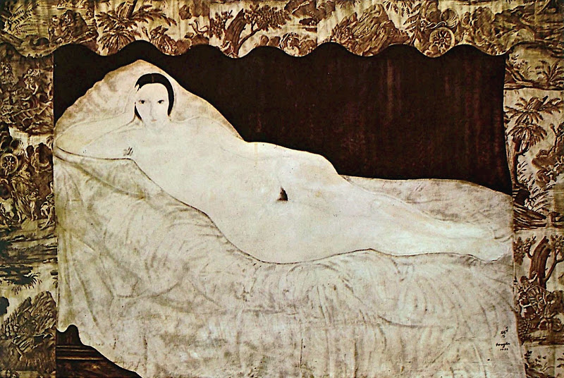

Fujita Tsuguharu, *Nude Reclining Amidst Toile Fabric* (*Nu couché à la toile de Jouy*), 1922. Oil on canvas. Musée d'Art Moderne de la Ville de Paris, France.

**References and further reading**

Birnbaum, P. (2006) *Glory in a Line: A Life of Foujita, the Artist Caught Between East and West*. New York: Faber and Faber, Inc.

Miyata Junichi. (2006) “Fujita Tsuguharu no jinuri: Nokosareta gafu to bôdo” (Fujita Tsuguharu’s Underpainting: Surviving Canvases and Boards), in *Tanjô 120nen: Fujita Tsuguharu ten* (Fujita Tsuguharu Exhibition: 120th Anniversary of his Birth) (Tokyo: NHK, 153-155.